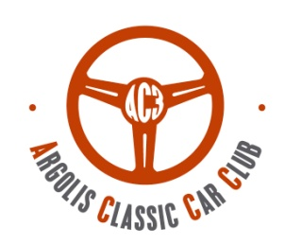
Touring

Regularity
Category

Young timer

ΤΕΑΜ:

Time Speed Distance
Historic Regularity Rally 07/03/2026

AC3 - Argolis Classic Car Club, tel: 2751 100798 , 6941502457 ,www.ac3.gr, info@ac3.gr

Participation fee 120.00 € (Touring 60.00 € )
includes: Vehicle Insurance, Timing, results, Prizes, Forms, Award Ceremony & Other Expenses. Arglolis Classic Car Club
Winbank/ PEIRAIOS BANK : 5500117516289
IBAN: GR 74 0172 5000 0055 0011 7516 289 Verification numper 998141419
(reason: your full name) Bank charges are borne by the depositor

The undersigned participant / driver / co-driver of the person declared in the T.S.D. Regularity Rally 07/03/2026, I declare that I I have studied and accept the regulations of the event and participate at my own risk and that I will not consider the Organizers ,the executives of the organization, and the Argolis Classic Car Club responsible for any accident or injury during the match. I also declare that I have full knowledge of the rules and regulations issued by FIVA and EO FILPA covering and controlling the matches and I guarantee to respect these instructions and regulations. I certify that Everything I state in this statement is true. I agree with article 5.6 of the event regulations that my personal information will be used for the following purposes: vehicle insurance, posting images, internet and could be transmitted for promotion or application. If consent is not given, participation in this event is not possible. Consent can be withdrawn at any time on 6941502457. Signatories acknowledge all terms and obligations of the event.

Category
CAR INFORMATION

Date
Signature
Manufacturer
Τype
Year of manufacture

Cubic Capacity
Card FIVA / FIA
Registration Numper nnnΚΥΚΛΟΦΟΡΙΑΣ

ENTRY FORM
HISTORIC REGULARITY RALLY 24-25/9/2022

DRIVER
CO DRIVER

NAME
EMAIL
MOBILE
NATIONALITY
ADDRESS
SURNAME

