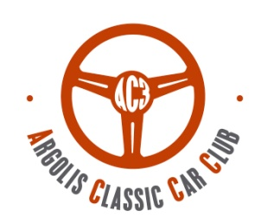
Classic Average speed
Touring Sport check points

Regularity average speed
Category E .F.G.H

Young timer

ΤΕΑΜ:

19th RALLY DANAON
08-09 /11 /2025

AC3 - Argolis Classic Car Club, tel: 2751 100798 , 6941502457,www.ac3.gr, info@ac3.gr

Participation fee 200 € (Classic category 180 € )
includes: Lunch ,Vehicle Insurance, Timing, results, Prizes, Forms, & Other Expenses.
Winbank/ PEIRAIOS BANK : 6611-136387-767
IBAN: GR82 0171 6110 0066 1113 6387 767
Account holder: Theodosia Uli
(reason: Ac3 & your full name) Bank charges are borne by the depositor

The undersigned participant / driver / co-driver of the person declared in the 19th RALLY DANAON 2025, I declare that I participate at my own risk and that I will not consider the Organizers,the executives of the organization, and the Argolis Classic Car Club responsible for any accident or injury during the match. I also declare that I have full knowledge of the rules and regulations issued by FIVA and EO FILPA covering and controlling the matches and I guarantee to respect these instructions and regulations. I certify that Everything I state in this statement is true. I agree that my personal information will be used for the following purposes: vehicle insurance, posting images, internet and could be transmitted for promotion or application. If consent is not given, participation in this event is not possible. Consent can be withdrawn at any time on 6941 502457. Signatories acknowledge all terms and obligations of the event.

TIMING
CAR INFORMATION

Date
Signature
Manufacturer
Τype
Year of manufacture

Cubic Capacity
Card FIVA / FIA
Registration Numper nnnΚΥΚΛΟΦΟΡΙΑΣ

ENTRY FORM
HISTORIC REGULARITY RALLY 24-25/9/2022

DRIVER
CO DRIVER

NAME
EMAIL
MOBILE
NATIONALITY
ADDRESS
SURNAME

